Trong HomeAdminController:

[Route("Themsanpham")]

[HttpGet]

public IActionResult ThemSanPhamMoi()

{

return View();

}

[Route("Themsanpham")]

[HttpPost]

[ValidateAntiForgeryToken]

public IActionResult ThemSanPhamMoi(TDanhMucSp sanpham)

{

if (ModelState.IsValid)

{

csdl.TDanhMucSps.Add(sanpham);

csdl.SaveChanges();

return RedirectToAction("Danhmucsanpham");

}

return View(sanpham);

}

Add view cua ThemSanPhamMoi() -> Razor View -> Create -> TDanhMucSp

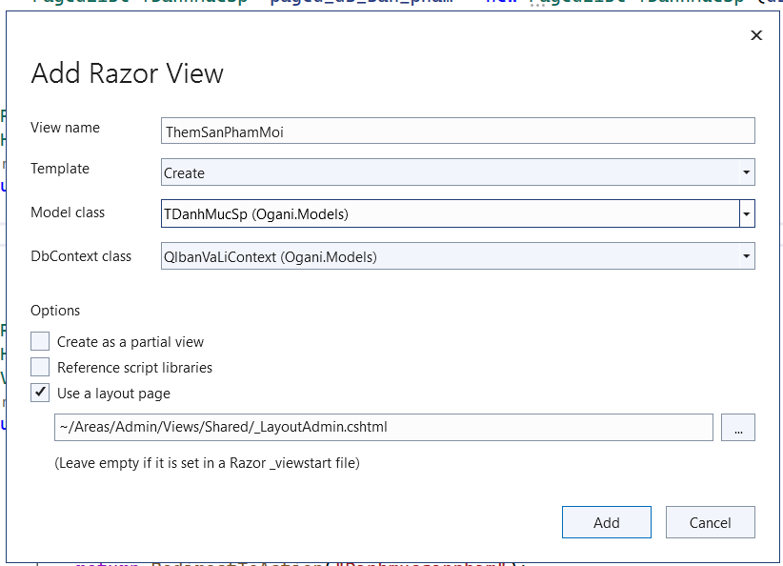

Them: @addTagHelper \*, Microsoft.AspNetCore.Mvc.TagHelpers

Trong the form them method=”post”

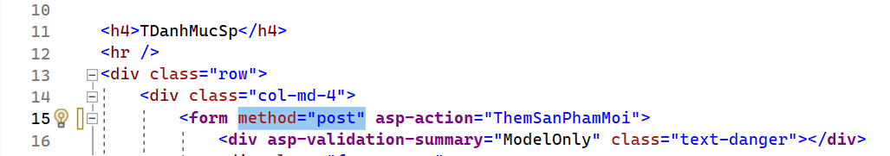

Trong HomeAdminController: viet lai ham ThemSanPhamMoi()

[Route("Themsanpham")]

[HttpGet]

public IActionResult ThemSanPhamMoi()

{

ViewBag.MaChatLieu = new SelectList(csdl.TChatLieus.ToList(), "MaChatLieu", "ChatLieu");

ViewBag.MaHangSx = new SelectList(csdl.THangSxes.ToList(), "MaHangSx", "HangSx");

ViewBag.MaNuocSx = new SelectList(csdl.TQuocGia.ToList(), "MaNuoc", "TenNuoc");

ViewBag.MaLoai = new SelectList(csdl.TLoaiSps.ToList(), "MaLoai", "Loai");

ViewBag.MaDt = new SelectList(csdl.TLoaiDts.ToList(), "MaDt", "TenLoai");

return View();

}

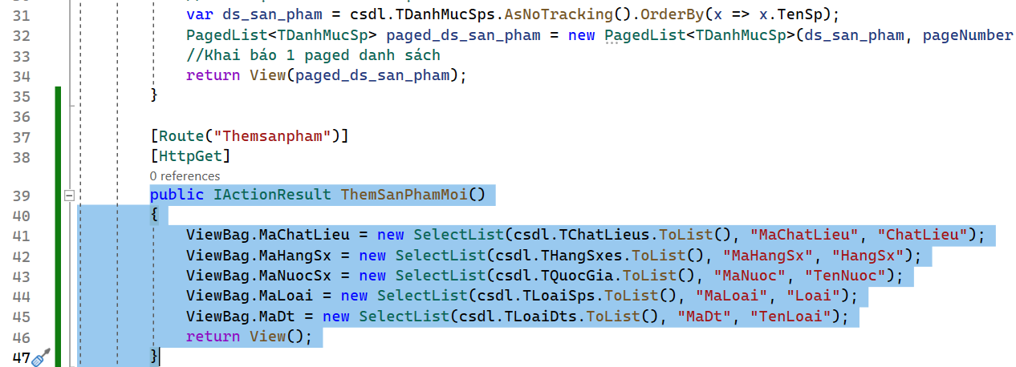

Trong file DanhMucSanPham.cshtml:

Them: @addTagHelper \*, Microsoft.AspNetCore.Mvc.TagHelpers

Doi Create -> Themsanphammoi

